**Aryaman Mishra**

**19BCE1027**

**Exercises**

**Pre-requisite: We will assume you are moderately familiar with basic concepts in Python**

**Dataset : Airline, Airport and Route datasets**

**Reference : (https://www.dataquest.io/blog/python-data-visualization-libraries/)**

**Pre Processing : Assign Column Headers to the given datasets**

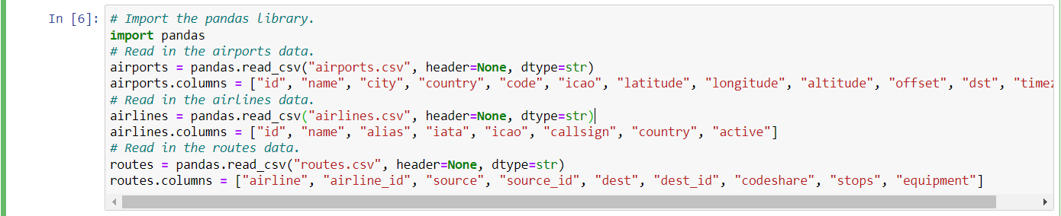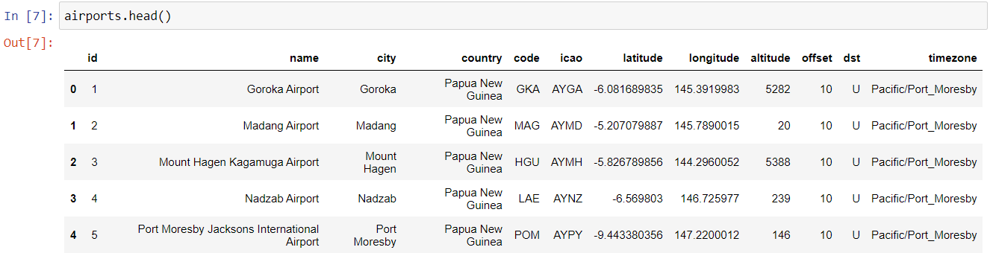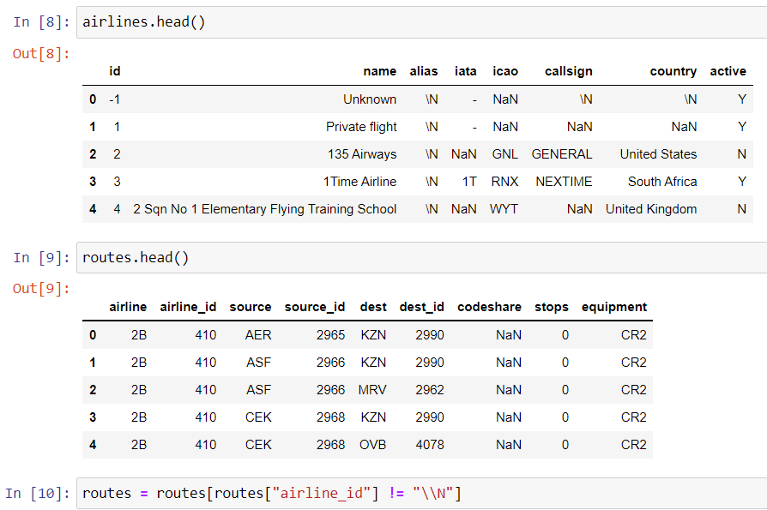

**Make histogram for route length, bin the values into ranges and count how many routes fall into each range**

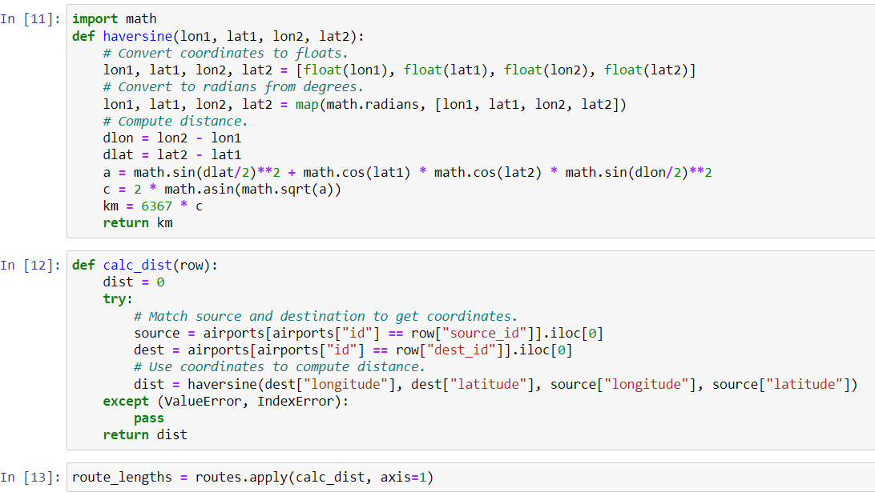

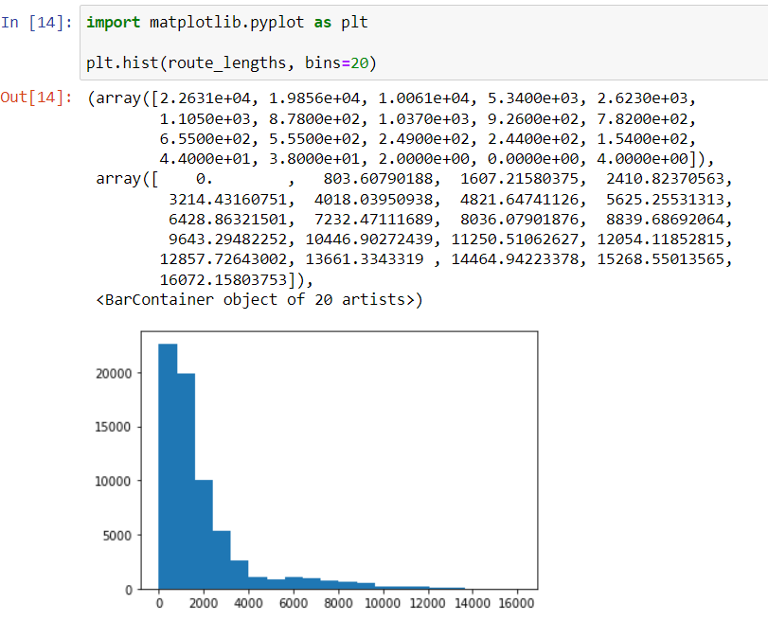

**Use seaborn for route dataset (route Length)**

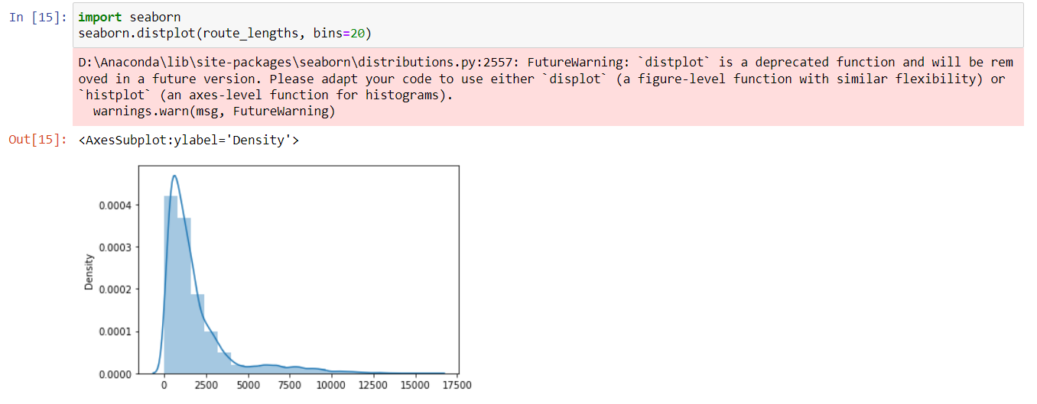

**Bar chart - plot each airline against the average route length each airline flies**

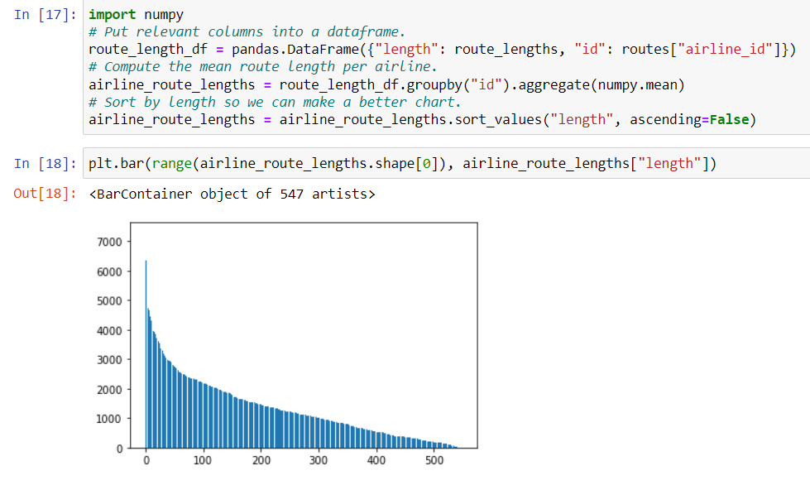

**Create a scatter plot comparing the airline ids to the name lengths**

